1 John 5:9-13 (NASB)
^{9 (NASB)} If we receive the testimony of men, the testimony of God is greater; for the testimony of God is this, that He has testified concerning His Son.
¹⁰ The one who believes in the Son of God has the testimony in himself; the one who does not believe God has made Him a liar, because he has not believed in the testimony that God has given concerning His Son.
¹¹ And the testimony is this, that God has given us eternal life, and this life is in His Son.
¹² He who has the Son has the life; he who does not have the Son of God does not have the life.
13. These things I have written to you who believe in the name of the Son of God, so that you may know that you have eternal life.

[biblestudymanuals.net] -1- [727-204-8189)

1 John 5:9-13 (NASB)
^{9 (NASB)} If we receive the testimony of men, the testimony of God is greater; for the testimony of God is this, that He has testified concerning His Son.
¹⁰ The one who believes in the Son of God has the testimony in himself; the one who does not believe God has made Him a liar, because he has not believed in the testimony that God has given concerning His Son.
¹¹ And the testimony is this, that God has given us eternal life, and this life is in His Son.
¹² He who has the Son has the life; he who does not have the Son of God does not have the life.
13. These things I have written to you who believe in the name of the Son of God, so that you may know that you have eternal life.

[biblestudymanuals.net] -1- [727-204-8189)

NOTE:
Use backspace to position CROSSROADS PICTURES at 2ND & 3RD columns of page #2.

Then print out a set of page #1’s.
Then flip over the page to other side and print out page #2’s.

Use a scissors to trim.

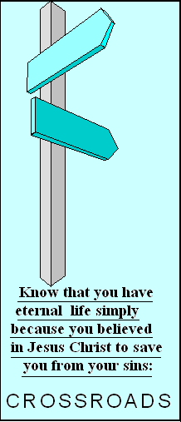
Know that you have eternal life simply because you believed in Jesus Christ to save you from your sins:

Know that you have eternal life simply because you believed in Jesus Christ to save you from your sins:

